

**Benefits Management Tools:  
Claim Notification Letters**

**Version: 1.2  
Launch: June 9, 2025**

**Revision History**

| Date | Version | Description | Author |
| --- | --- | --- | --- |
| 6/9/2025 | 1.2 | Added automated email notification | Saliha Ghaffar |
| 3/27/24 | 1.1 | Updated to include other development letters | Jacob Worrell |
| 9/30/22 | 1 | Product Debut | Jacob Worrell |

**Table of Contents**

1. Notification Letters Overview

2. User Access

3. Navigation

4. Functionality

5. Major Issues and Error Messages

6. Email Notifications

## 1. Notification Letters Overview

The Claim Notification Letters tool, a crucial feature of the Claims Status Tool, enables Veterans to access and download decision letters and claim development letters, such as those issued when VA requests additional evidence. In the future, it may also include Board Appeals decision letters.

## 2. User Access

Users must be logged in to VA.gov or the VA Health and Benefits mobile app and have a claim on file to access claim letters.

## 3. Navigation

**Direct URL:** <https://va.gov/track-claims/your-claims-letters>

Users can also navigate to claim letters by following links to “Check your claim or appeal status” from the VA.gov home page’s list of top pages or the mega-menu’s “Disability” sub-menu, as shown in the screenshot below:

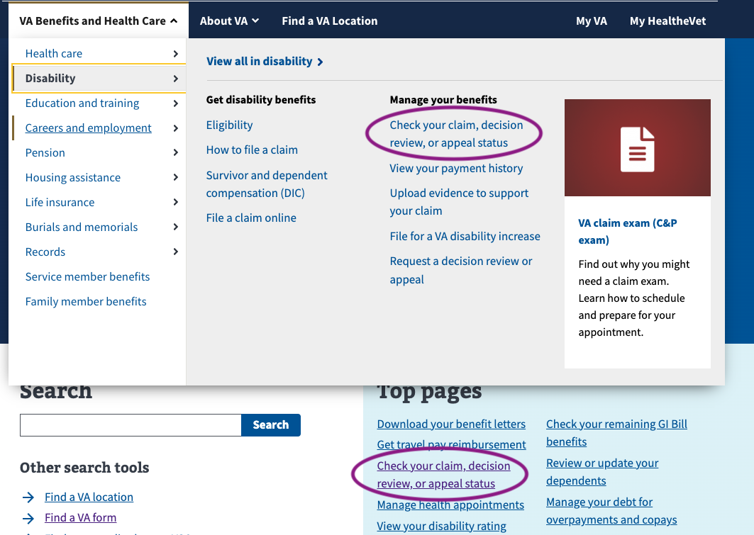

From the Claim Status Tool landing page (URL: <https://staging.va.gov/track-claims/your-claims>), users get a link to “Your claim letters.”

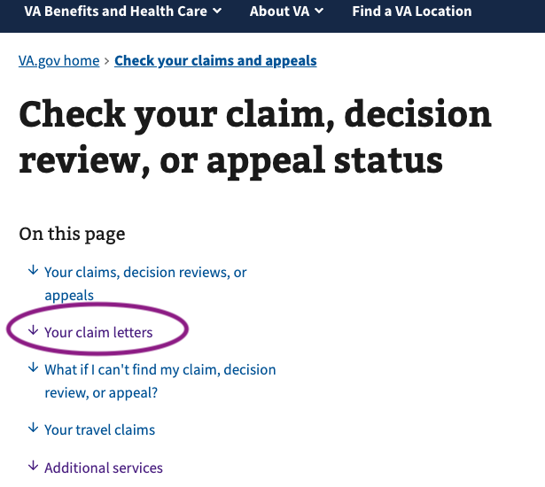

Clicking this link brings the user to a list of their claim letters.

Alternatively, they can navigate from the Claim Status Tool’s landing page to the details of a specific claim that indicates we sent a development letter or a decision letter, such as in the following screenshots:

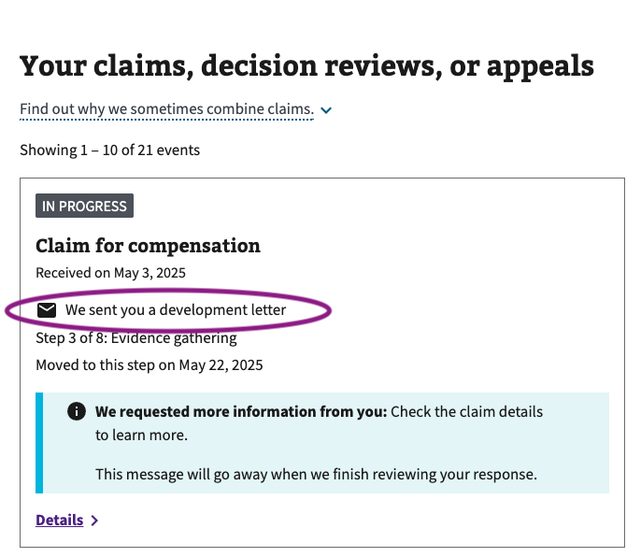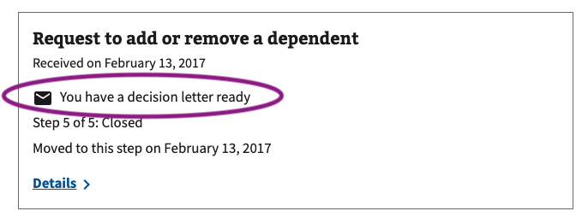

When they click on the link to “Details,” the details page will include a link to the claim letters, such as in the following screenshot:

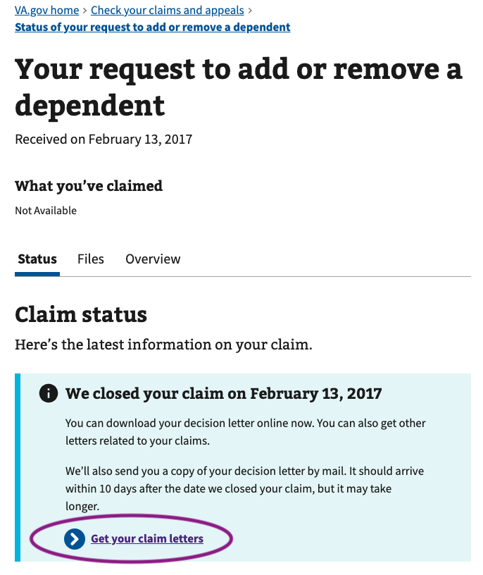

## 4. Functionality

Within the Claim Letters page, a Veteran can click on one of the “Download (date) letter” links and download their notification letter.

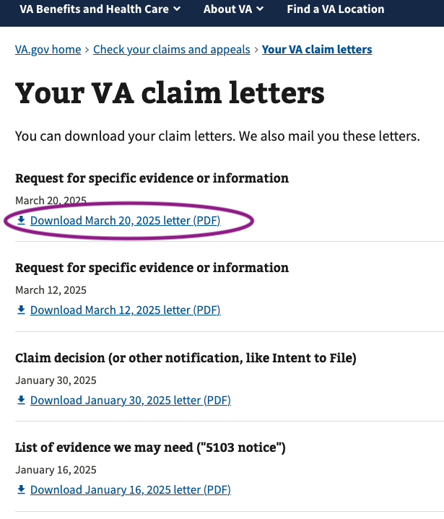

Once a Veteran clicks a “Download letter” link, the behavior is browser- and user-setting-specific. The user can download the letter immediately or display a preview in a browser window.

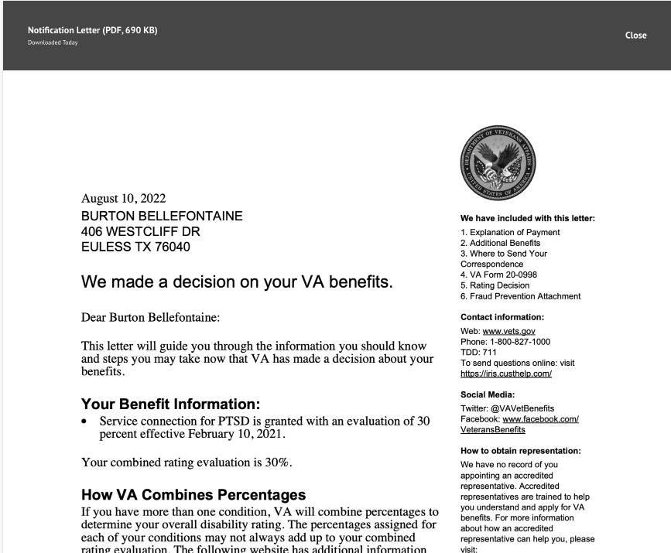

## 5. Major Issues and Error Messages

Error messages are in place for VA maintenance and other service disruptions. In both cases, the user is notified and asked to check back later.

## 6. Email Notifications

As of June and July 2025, VA.gov will begin sending email notifications when a decision letter is available regarding a disability compensation claim. Later in 2025, we will start sending email notifications for other types of decision letters, including Supplemental Claims and Higher Level Reviews. When a Veteran’s Decision Letter becomes available, an automated notification is triggered and sent directly to the Veteran’s email via VA Notify if we have an email address on file. This notification indicates that the Decision Letter is ready for download and includes a link to view the letter on VA.gov, which directs users to their Claim Letters in the Claims Status Tool (CST).

